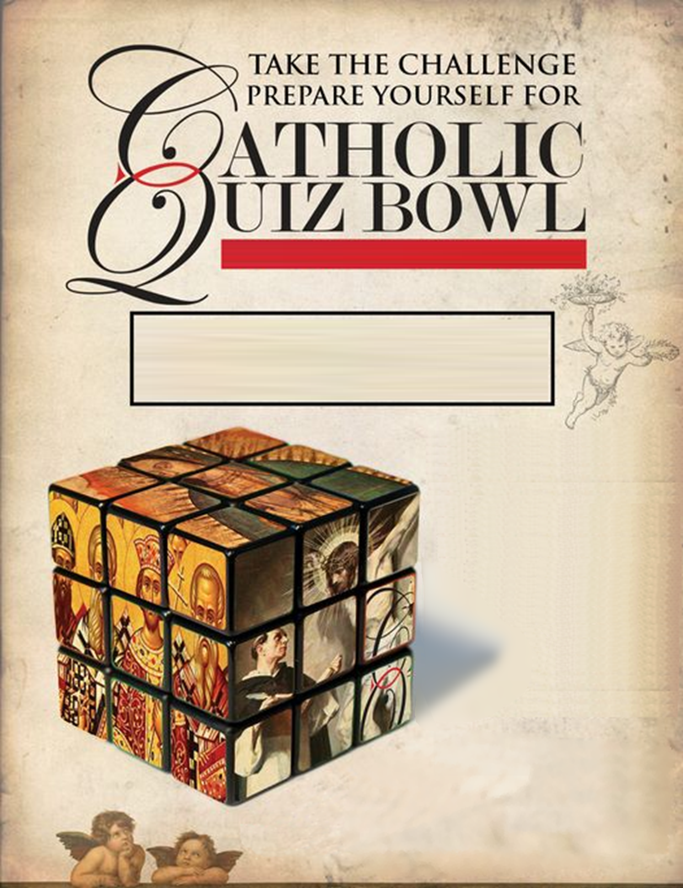

* FOUR ROUNDS
* For Middle school students registered in STM RE program

Sponsored by your local

Knights of Columbus, Council #3640

REGISTER. CONTACT   
 EVAN BAUMBERGER, 605-692-8309  
 discipleship@stmbrookings.org

* FEB 22ND DEADLINE TO
* TEAM COMPETION  
  + 4 PER TEAM IS IDEAL  
  + 5 MEMBER MAXIMUM  
  (TEAMS WITH 5 MUST HAVE 1 MEMBER SIT OUT EACH ROUND)
* MEDALS & DQ GIFT CARDS TO MEMBERS OF 1ST, 2ND, & 3RD PLACE

From 1pm to ~3:30pm

SATURDAY FEB 25TH

SAINT THOMAS MORE CATHOLIC CHURCH